

TetraxWeb

Marketing Team

Senior Project

By

**Jad Sharafeldeen Chehayeb**

Submitted to the School of Arts & Science of the

Lebanese International University

In part of fulfillment of the requirements for the degree of

**BACHERLOR OF SCIENCE IN COMPUTER SCIENCE**

**Supervised by: Dr. Bilal Owaidat**

Spring 2022 – 2023

Dedication:

Dear Parents, Friends, Instructor, and University,

I am writing this letter with overflowing gratitude as I stand at the culmination of my senior project. It is with immense honor and heartfelt appreciation that I dedicate this achievement to each and every one of you who has played an invaluable role in my journey.

First and foremost, to my loving parents, your unwavering support and unconditional love have been the foundation upon which I have built my aspirations. Your constant encouragement, sacrifices, and belief in my abilities have propelled me forward, even in the face of adversity. I am forever grateful for the countless sacrifices you have made to provide me with opportunities and for your unshaken presence by my side, cheering me on every step of the way.

To my dear friends, you have been my pillars of strength throughout this demanding journey. Your determined faith in my abilities, your words of encouragement, and your firm support have pushed me to surpass my own expectations. Together, we have faced challenges, celebrated victories, and provided each other with the enduring support and camaraderie that is truly priceless. I am grateful for the memories we have shared and for the bonds that have formed, knowing that your friendships will endure beyond this project.

To my dedicated instructor **Doctor Bilal Owaidat**, your guidance and mentorship have been instrumental in shaping my growth and success. Your passion for teaching and commitment to our development have inspired me to strive for excellence. Your expertise, patience, and willingness to go the extra mile have not only imparted knowledge but also instilled in me the confidence to tackle complex problems and embrace new ideas. I am grateful for your abiding belief in my abilities and for pushing me beyond my comfort zone, allowing me to reach new heights.

Lastly, to my esteemed **Lebanese International University**, you have provided me with an exceptional environment to nurture my intellectual curiosity and personal growth. The resources, opportunities, and educational experiences you have offered have been pivotal in shaping my academic journey. The faculty members, staff, and fellow students have formed a vibrant community that has broadened my horizons and challenged me to think critically. I am grateful for the platform you have provided me to learn, grow, and prepare for a successful future. I am forever indebted to you for the profound influence you have had on my life.

Thank you for being my constant source of inspiration, strength, and support. I am truly honored to dedicate my senior project to each one of you.

Acknowledgement:

I have poured my heart and soul into my project, "TetraxWeb." The completion of this project on time and its realization according to my vision would not have been possible without the exceptional support and guidance of certain individuals and organizations. I would like to express my heartfelt thanks to all of them.

First and foremost, I am deeply grateful to my professor, Bilal Owaidat, for his unwavering guidance and constant supervision. His expertise and continuous support have played a crucial role in shaping the success of my project. His invaluable advice and provision of necessary information have propelled me in the right direction, enabling me to achieve my goals effectively.

I would also like to extend my sincere appreciation to my parents and friends for their unwavering encouragement and support throughout this journey. Their belief in my abilities and their constant motivation have been instrumental in my ability to complete the project flawlessly and within the specified timeframe. I am incredibly grateful for their unwavering support, which has helped me overcome challenges and achieve excellence.

To all those who have contributed to the success of my project, "TetraxWeb," I extend my deepest thanks and appreciation. Your support, guidance, and assistance have made a significant impact on my journey, and I am truly grateful for your contributions.

Abstract:

TetraxWeb is an advertising team specializing in website development, animation, graphic design, and social media expertise. Our website, TetraxWeb, offers a comprehensive online platform where users can access our services and communicate with us. Only logged-in or signed-up users have access to view the website's content and purchase our services, as well as send us messages for inquiries and support. Administrators, who are logged-in users with special privileges, have additional capabilities such as adding, removing, and updating services, as well as accessing the entire website. Furthermore, the website provides a password reset option for users who have forgotten their login credentials. TetraxWeb's aim is to provide a seamless and user-friendly experience, allowing individuals and businesses to benefit from our diverse range of advertising services.

**List of Tables:**

Table 1- login use case................................................................................................................................

Table 2 – Signup use case ...........................................................................................................................

Table 3 – logout use case ..........................................................................................................................

Table 4 – Reset password use case............................................................................................................

Table 5 – Edit use case...............................................................................................................................

Table 6 – Buy use case...............................................................................................................................

Table 7 – Search use case...........................................................................................................................

Table 8 – send use case...............................................................................................................................

**List of Figures:**

Figure 1- Use Case Diagram..........................................................................................................................

Figure 2 - ER-Diagram ..................................................................................................................................

Figure 3 - Relational Diagram .......................................................................................................................

Figure 4 / 5 – Signin/Signup Page Slider.........................................................................................................

Figure 6- Home Page.....................................................................................................................................

Figure 7 – Our Products Page........................................................................................................................

Figure 8 – Our Services Page..........................................................................................................................

Figure 9 – Graphic Design Page.....................................................................................................................

Figure 10 – Advertising Page .........................................................................................................................

Figure 11 – Animation Page..........................................................................................................................

Figure 12 – Website Page ...........................................................................................................................

Figure 13 – Digital Marketing Page...............................................................................................................

Figure 14 – About us page......................................................................................................................

Figure 15 – Contact us page ...................................................................................................................

Figure 16 – Admins Page.........................................................................................................................

**Chapter 1**

In this chapter, we are going to state the problem that we find, and how our project helps in

solving it, in addition to mentioning technology constraints and our objective, then explaining all

of them in details.

**Introduction:**

In today's competitive business landscape, effective advertising and marketing strategies play a pivotal role in driving success. However, finding a reliable and comprehensive advertising team that offers a diverse range of services can be a daunting task. This is where our project comes in. We have developed a website that serves as a centralized platform for businesses and individuals to access an advertising team that excels in services like website design, graphic design, animation videos, and social media expertise. By providing a one-stop solution, our project aims to streamline the process, save time, and ensure consistent quality, ultimately helping clients achieve their marketing goals efficiently. This introduction sets the stage for the significance of our project in addressing the challenges faced by businesses and individuals when it comes to accessing reliable advertising services.

**Objective:**

The objective of our project is to create a user-friendly website that serves as a centralized platform for businesses and individuals to access a comprehensive range of advertising services. By offering services such as website design, graphic design, animation videos, and social media expertise, our project aims to streamline the process of finding and engaging with an advertising team. We strive to improve efficiency by eliminating the need for clients to engage with multiple providers, saving them time and reducing communication challenges. Furthermore, our objective is to ensure the delivery of high-quality and consistent services, building trust and reliability among our clients. Through a secure and reliable platform, we aim to provide an efficient and convenient solution that helps businesses and individuals achieve their marketing goals effectively.

**Scope:**

The scope of our project encompasses the development of a functional and visually appealing website that offers a wide range of advertising services. This includes the following aspects:

User Interface (UI) Design: Creating an intuitive and visually appealing user interface that is easy to navigate and provides a seamless user experience for both customers and administrators.

Service Offerings: Implementing sections dedicated to various advertising services, such as website design, graphic design, animation videos, and social media expertise. Each service section will provide comprehensive information, examples of previous work, and pricing details.

User Registration and Authentication: Developing a secure user registration and authentication system that allows customers and administrators to create accounts, log in, and access their respective dashboards.

Customer Dashboard: Designing a personalized dashboard for customers that displays their purchased services, invoices, and allows them to make new service purchases.

Admin Dashboard: Creating an admin dashboard that grants administrators the ability to update, delete, and add services. This includes functionalities to manage service details, pricing, and showcase portfolios.

Payment Integration: Integrating a secure and reliable payment gateway to facilitate online transactions for service purchases.

Portfolio Showcase: Developing a section to showcase past projects, highlighting the expertise and quality of the advertising team's work.

Contact and Inquiry Form: Including a contact form for visitors to reach out for inquiries, further information, or to request a quote.

Content Management System (CMS): Implementing a CMS that allows administrators to easily update and manage website content, including service descriptions, pricing, and portfolio items.

Responsive Design: Ensuring that the website is responsive and compatible across different devices and screen sizes, providing a consistent user experience.

Security Measures: Implementing appropriate security measures, including secure user authentication, data encryption, and protection against common web vulnerabilities.

The scope of our project focuses on developing a fully functional website that effectively addresses the needs of businesses and individuals seeking advertising services. We aim to create a robust and user-friendly platform that streamlines the process, saves time, and delivers high-quality results for our clients.

**Technology Constraints:**

Software needed: Visual studio code, Xampp, Web browser

Languages: php, javascript, jquery, html, css, mysql

Frameworks & libraries: bootstarp, ajax.

**Problem:**

The problem we have identified is the fragmentation and lack of convenience in accessing comprehensive advertising services. Businesses and individuals often struggle to find a single provider that offers a diverse range of advertising services, such as website design, graphic design, animation videos, and social media expertise. This leads to the need for engaging with multiple providers, resulting in inefficiencies, communication challenges, and increased costs. Furthermore, the process of finding and evaluating different providers can be time-consuming and overwhelming, making it difficult to ensure consistent quality and reliable results in advertising efforts.

**Solution:**

To address the problem of fragmented and inconvenient access to advertising services, our solution is to create a website that serves as a centralized platform for businesses and individuals to find and engage with a comprehensive advertising team. Our website will offer a wide range of services, including website design, graphic design, animation videos, and social media expertise. By bringing together these services under one platform, we aim to streamline the process and provide a convenient solution for clients.

Through our website, clients will have easy access to a professional advertising team that can cater to their diverse needs. They will no longer need to search for and communicate with multiple providers, saving time and reducing the complexities of coordinating different services. By offering a one-stop solution, we provide convenience and efficiency, simplifying the advertising process for our clients.

Moreover, our solution ensures consistent quality across all advertising aspects. By providing a dedicated team with expertise in various services, we maintain a high standard of work and deliver reliable results to our clients. They can trust that their marketing efforts will be handled by professionals who excel in each area, ensuring the effectiveness and impact of their advertising campaigns.

Additionally, our website will facilitate transparent communication and collaboration between clients and our advertising team. Clients can easily communicate their requirements, provide feedback, and monitor the progress of their projects through our platform. This improves the overall client experience, fostering better relationships and satisfaction.

Overall, our solution aims to provide a centralized platform that offers convenience, efficiency, and quality in accessing advertising services. By eliminating the fragmentation and complexities associated with multiple providers, we empower businesses and individuals to achieve their marketing goals effectively and efficiently.

**Chapter 2**

This chapter describes both functional and non-functional requirements for our project. In

addition to that it shows the UML use cases and scenarios with all related details.

**2.1 Functional Requirements:**

Functional requirements define the specific features and functionalities that our project must include. These requirements are directly related to the core functionalities and objectives of our website. The functional requirements for our project include:

**User Registration and Authentication:**

Users should be able to create an account by providing necessary details such as name, email, and password.

The system should authenticate users during the login process, verifying their credentials against stored user information.

**Customer Dashboard:**

Customers should have access to a personalized dashboard upon login, displaying their purchased services, invoices, and payment history.

Customers should be able to browse and select services for purchase from a list of available options.

The dashboard should provide an option for customers to track the progress of their projects and communicate with the advertising team.

Admin Dashboard:

Admins should have access to an administrative dashboard upon login, providing options to update, delete, and add services.

Admins should be able to manage service details, pricing, and portfolios.

The admin dashboard should allow admins to view and manage customer information, invoices, and project statuses.

**Password Reset:**

Users should have the ability to reset their password if forgotten.

A password reset functionality should be available, allowing users to provide their registered email address and receive a password reset link.

**Service Purchase and Payment:**

Customers should be able to select services and make online payments securely through integrated payment gateways.

The system should generate invoices and send payment confirmation to customers.

**Portfolio Showcase:**

The website should include a section to showcase the advertising team's portfolio, highlighting their previous work and expertise.

**Contact and Inquiry Form:**

A contact form should be provided, allowing visitors to send inquiries, request quotes, or seek further information about the services offered.

**2.2 Non-Functional Requirements:**

Non-functional requirements specify the qualities and characteristics of our project, focusing on aspects beyond specific functionalities. These requirements define the desired attributes of our website. The non-functional requirements for our project include:

**User-Friendly Interface:**

The website should have an intuitive and user-friendly interface that is easy to navigate, ensuring a positive user experience for both customers and admins.

The design should be visually appealing, incorporating appropriate branding and aesthetics.

**Performance and Scalability:**

The website should be optimized for performance, ensuring fast loading times and responsive interactions.

The system should be scalable to accommodate increased traffic, data volume, and potential future expansions.

**Security:**

The website should implement secure user authentication mechanisms, protecting user data and preventing unauthorized access.

Appropriate encryption techniques should be used to secure sensitive information, such as passwords and payment details.

**Compatibility:**

The website should be compatible with popular web browsers (e.g., Chrome, Firefox, Safari) and various devices (e.g., desktops, tablets, smartphones), ensuring consistent functionality and appearance.

**Reliability and Availability:**

The website should be reliable, with minimal downtime and regular backups to prevent data loss.

Adequate hosting and server infrastructure should be in place to ensure the availability of the website.

**2.3 UML Use Cases and Scenarios:**

UML (Unified Modeling Language) use cases and scenarios provide a visual representation of how users interact with the system and describe specific user actions and system responses. The use cases and scenarios for our project include:

**User Registration:**

Use Case: Register User

Scenario: A new user fills out the registration form with their details, including name, email, and password. The system validates the information and creates a new user account.

**User Login:**

Use Case: User Login

Scenario: A registered user enters their credentials on the login page. The system verifies the provided information and grants access to the appropriate dashboard (customer or admin).

**Service Purchase:**

Use Case: Purchase Service

Scenario: A logged-in customer browses the available services, selects the desired service, and proceeds to the checkout. The system calculates the total cost, generates an invoice, and redirects the user to the payment gateway.

**Admin Service Management:**

Use Case: Manage Services (Admin)

Scenario: An admin logs in to the admin dashboard, where they can view, update, delete, or add new services. The system updates the service information accordingly.

**Password Reset:**

Use Case: Reset Password

Scenario: A user clicks on the "Forgot Password" link and enters their registered email address. The system sends a password reset link to the provided email, allowing the user to set a new password.

These use cases and scenarios provide a comprehensive overview of the interactions and functionalities within our system, capturing the essential user actions and system responses.

In this chapter, we have outlined the functional and non-functional requirements for our project. We have also presented the UML use cases and scenarios, highlighting the user interactions and system behaviors. These requirements and use cases serve as the foundation for the subsequent phases of development, ensuring that our project meets the desired objectives and user expectations.

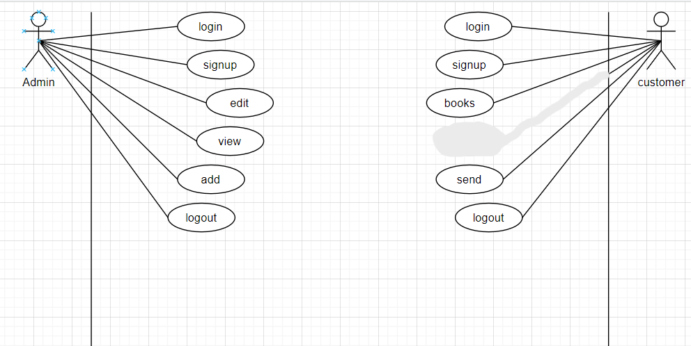

**2..3.1-Use Case scenarios (customer actor)**

In this part we will be explaining all of the mentioned use cases of the customer in details, regarding

primary actors, main flow, and the alternative one. In addition to a short description for each use case

making all points clear.

|  |
| --- |
| Use case name: Login |
| Actor: Admin, Customer |
| Brief Description: This case allows the admin and customer to login into the website |
| Basic Flow:   1. The user enters his user name or email and password. 2. Then the php code checks if the user exits and if the credentials are correct. 3. If the user exits and typed the right password he logs in. 4. If the user is admin he logs in as an admin |
| Alternative Flow:   1. If the user doesn’t exit an error messages shows user doesn’t exist and gives him the option to signup. 2. The user enters wrong credentials, he’s taken back to login page with an error. |
| Precondition:   1. User has to enter his password and user name or email. |
| Post-Condition:   1. In case user name and password are correct the user is logged in. |

|  |
| --- |
| Use case name: Signup |
| Actor: admin, customer |
| Brief Description: This case allows the admin and customer to signup to the website |
| Basic Flow:   1. The user enter his username or email, and password. 2. Then the php code checks if the user exits. 3. If the user is admin he logs in as an admin. |
| Alternative Flow:   1. If the user does exit an error messages shows user that he exists and gives him the option to login. 2. The user enters existing username or email, he’s taken back to sign page with an error. |
| Precondition:   1. User has to enter his password and user name or email. |
| Post-Condition:   1. In case user does not exist the sign up will be successful. |

|  |
| --- |
| Use case name: logout |
| Actor: admin, customer |
| Brief Description: This case allows the admin or customer to logout from the website |
| Basic Flow:   1. The user presses the logout button. 2. Then the php session ends. 3. The user logs out. |
| Alternative Flow:   1. If the user isn’t logged in the logout button does’t do anything. |
| Precondition:   1. User has to be logged in. |
| Post-Condition: None |

|  |
| --- |
| Use case name: Reset password |
| Actor: Admin, customer |
| Brief Description: This case allows the user to reset his password. |
| Basic Flow:   1. The user can reset the password for his account. |
| Alternative Flow:   1. If the user doesn’t have an account this option won’t work . |
| Precondition:   1. User has to be signed up. |
| Post-Condition:   1. In case the user exits, he may reset his password . |

|  |
| --- |
| Use case name: edit |
| Actor: Admin |
| Brief Description: This case allows the admin to edit the website |
| Basic Flow:   1. The admin can update, delete, and change the pricing of the packages. |
| Alternative Flow:   1. If the user is not an admin this option won’t be available . |
| Precondition:   1. User has to login as an admin. |
| Post-Condition:   1. In case the user is an admin, administrative options will be available . |

|  |
| --- |
| Use case name: view |
| Actor: Admin |
| Brief Description: This case allows the admin to view the website |
| Basic Flow:   1. The admin can customer messages. |
| Alternative Flow:   1. If the user is not an admin this option won’t be available . |
| Precondition:   1. User has to login as an admin. |
| Post-Condition:   1. In case the user is an admin, administrative options will be available . |

|  |
| --- |
| Use case name: Buy |
| Actor: Customer |
| Brief Description: This case allows the customer to buy a package. |
| Basic Flow:   1. The customer can buy packages. |
| Alternative Flow:   1. If the user is not a customer this option won’t be available . |
| Precondition:   1. User has to login as a customer. |
| Post-Condition:   1. In case the user is a customer, this option will be available . |

|  |
| --- |
| Use case name: search |
| Actor: Admin |
| Brief Description: This case allows the admin to search for a specific customer transaction. |
| Basic Flow:   1. The admin can search the transactions of any customer. |
| Alternative Flow:   1. If the user is not an admin this option won’t be available . |
| Precondition:   1. User has to login as an admin. |
| Post-Condition:   1. In case the user is an admin, this option will be available . |

|  |
| --- |
| Use case name: send |
| Actor: Customer |
| Brief Description: This case allows the customer to send a message. |
| Basic Flow:   1. The customer can send a message anytime and as many as he wants. |
| Alternative Flow:   1. If the user is not a customer this option won’t be available . |
| Precondition:   1. User has to login as a customer. |
| Post-Condition:   1. In case the user is a customer, this option will be available . |

**Chapter 3**

This chapter describes the system design, including the data base of our project, the related tables

and the relations between them.

**3.1-System Design:**

**3.1.1-ER-Diagram:**

This ER diagram visually represents the entities and their relationships. The primary keys (PK) and foreign keys (FK) are indicated to depict the relationships between the entities.

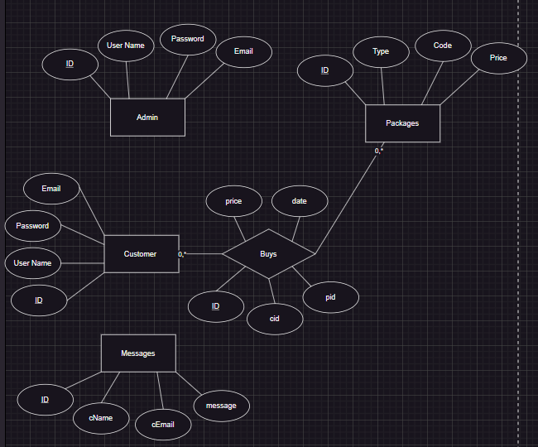

**Relational Diagram Figure:**

See figure 3 – Relational Diagram to see all the attributes of each entity, in addition to the

relations between entities.

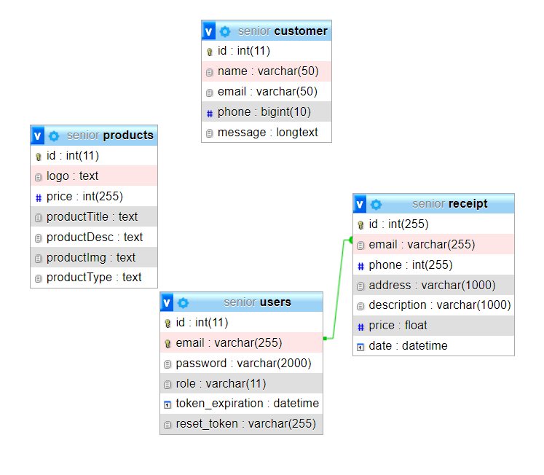

**Chapter 4: Implementation**

**4.1 Introduction:**

In this chapter, we will provide an overview of the design and layout of our website, highlighting the main roles and functionalities of each page and button. The implementation phase focuses on translating the requirements and design into a functional and visually appealing website.

**4.2 Website Design Overview:**

Our website will have a professional and user-friendly design, incorporating modern UI/UX principles to ensure an engaging and intuitive user experience. The layout will be responsive, adapting to different screen sizes and devices. Here is a brief description and images of the main pages and buttons within our website:

**4.2.1 - Sign in page:**

First page of the website where users can sign in if they already have an account

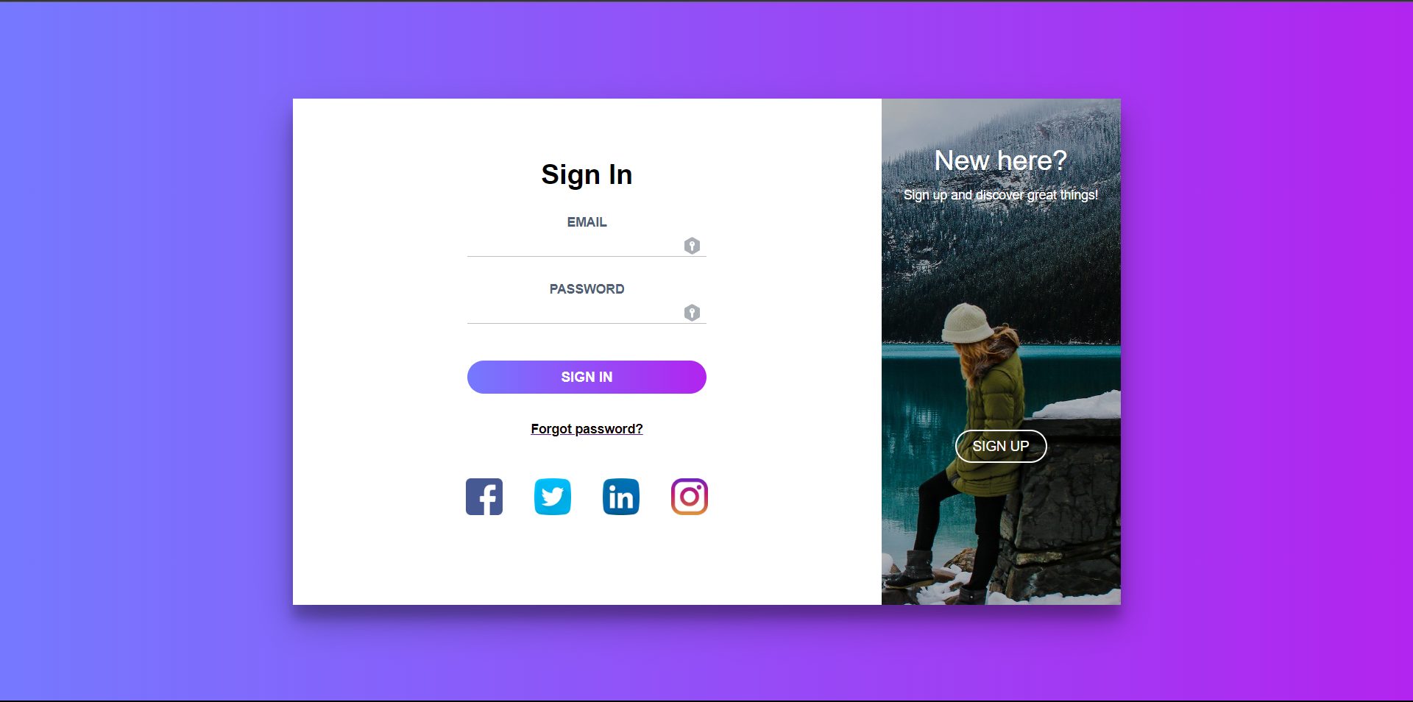

**4.2.2 – Sign up page:**

Still in the same page but if the user does not have an account he presses the sign up button to transition to sign up page with a cool and subtle animation, where he may create a new account.

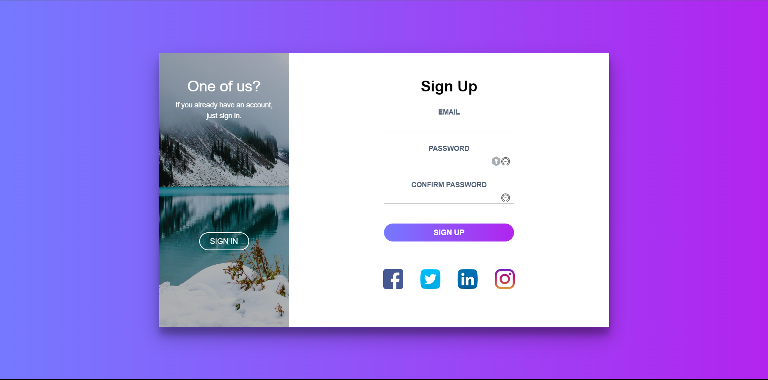

**4.2.3 – Home page:**

In this page the user may navigate to the other pages, and can sign out and check out our cool blob animation.

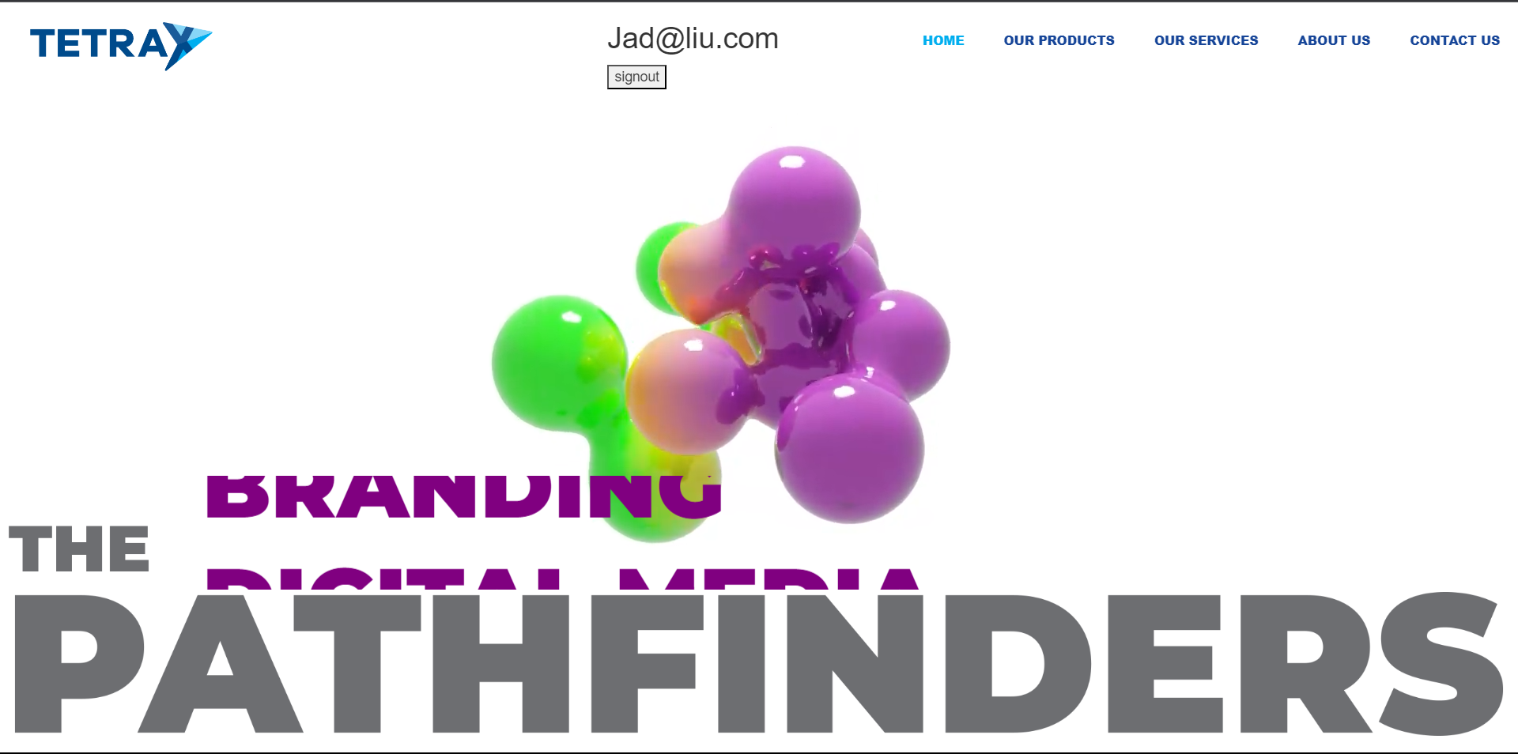

**4.2.4 – Products page:**

Here where a user as a customer is able to view and buy our services.

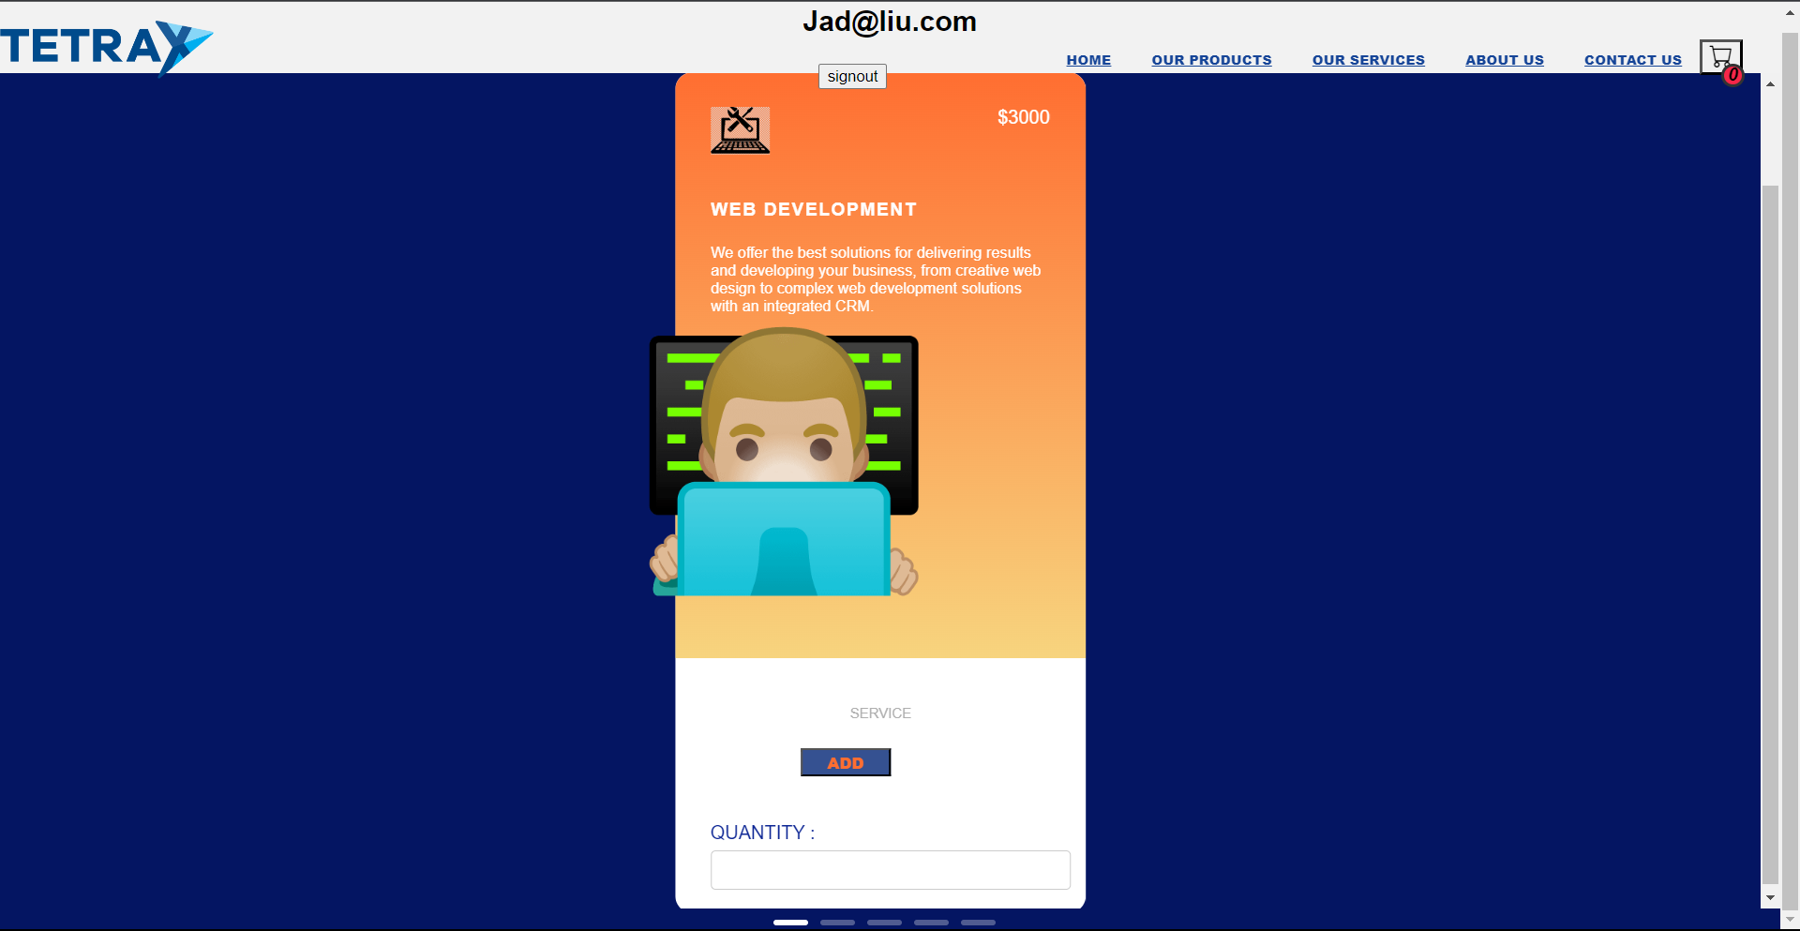

**4.2.5 – Our services page:**

Here the user can know more about what services we have and can click on each one of them to know more about each service.

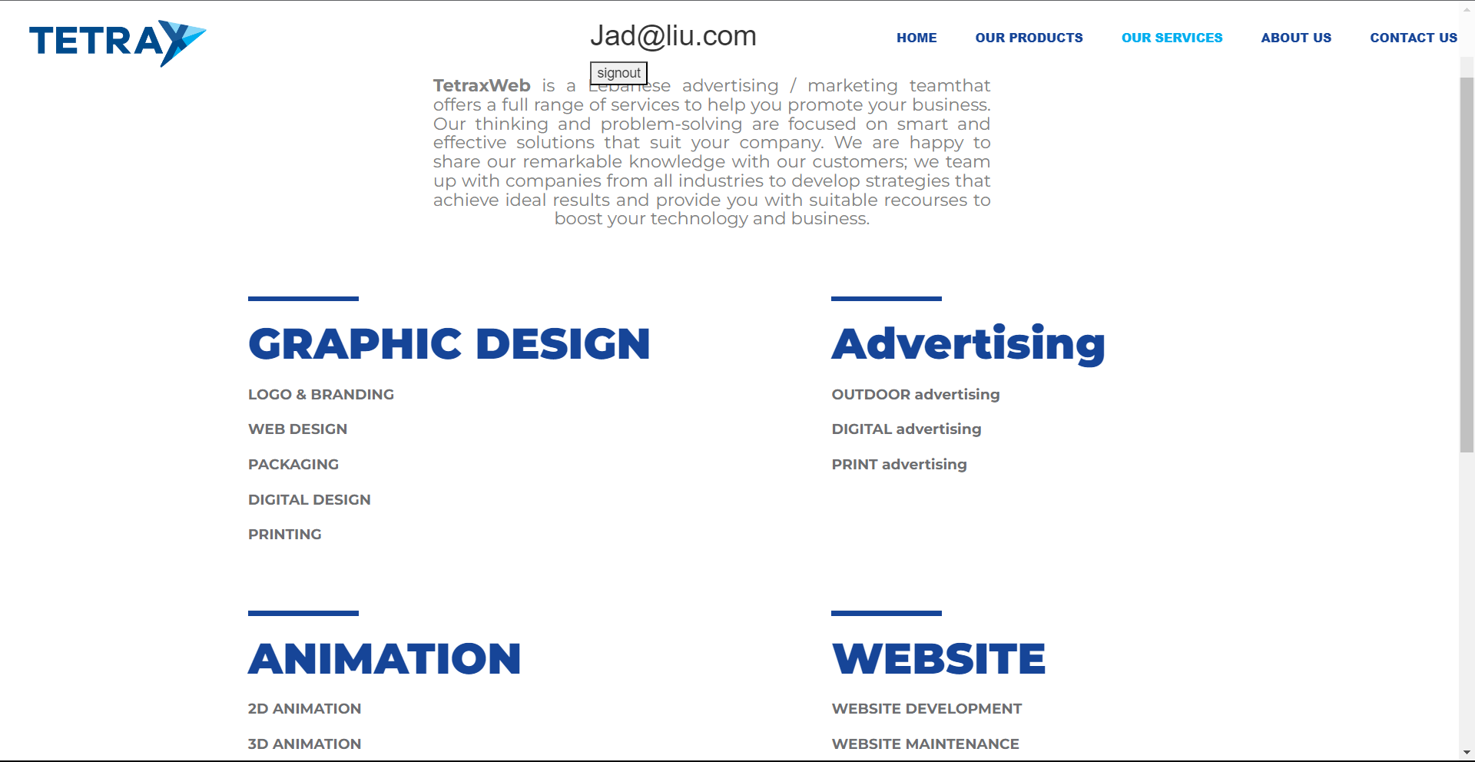

**4.2.6 -**

**Graphic Design page:**

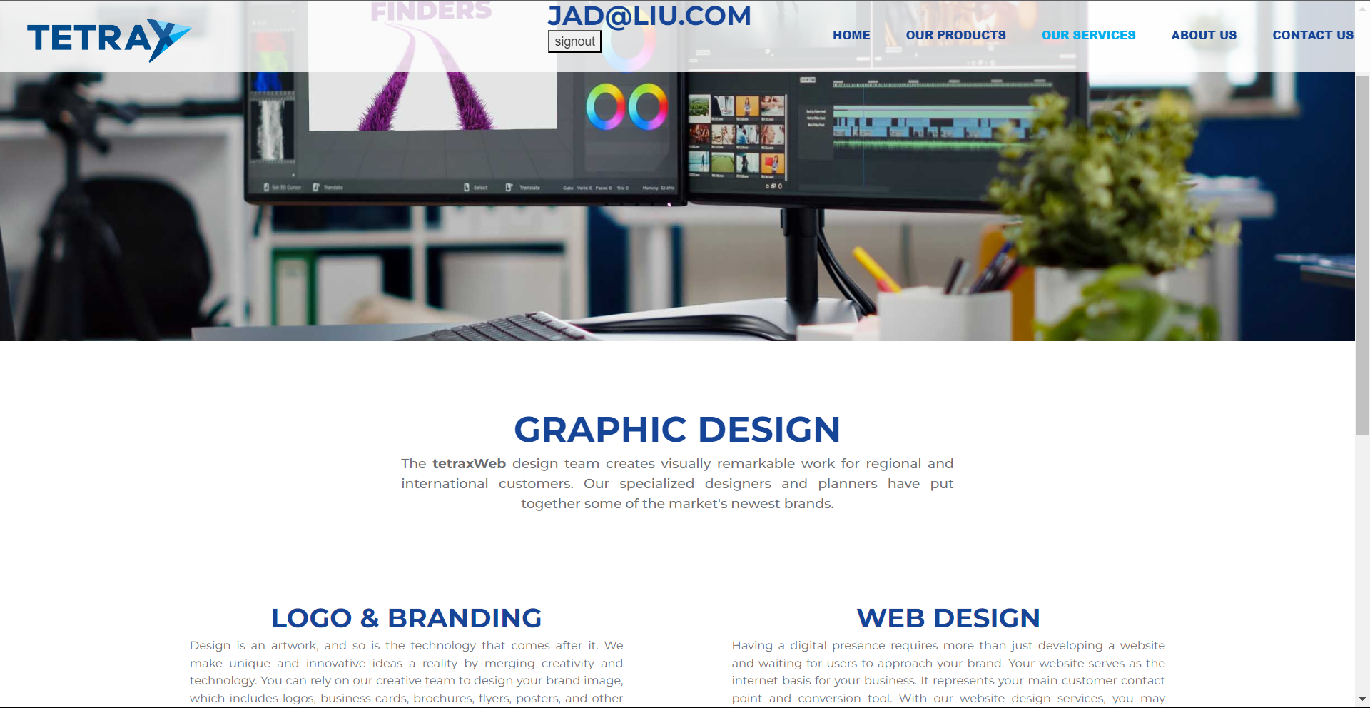

**Advertising page:**

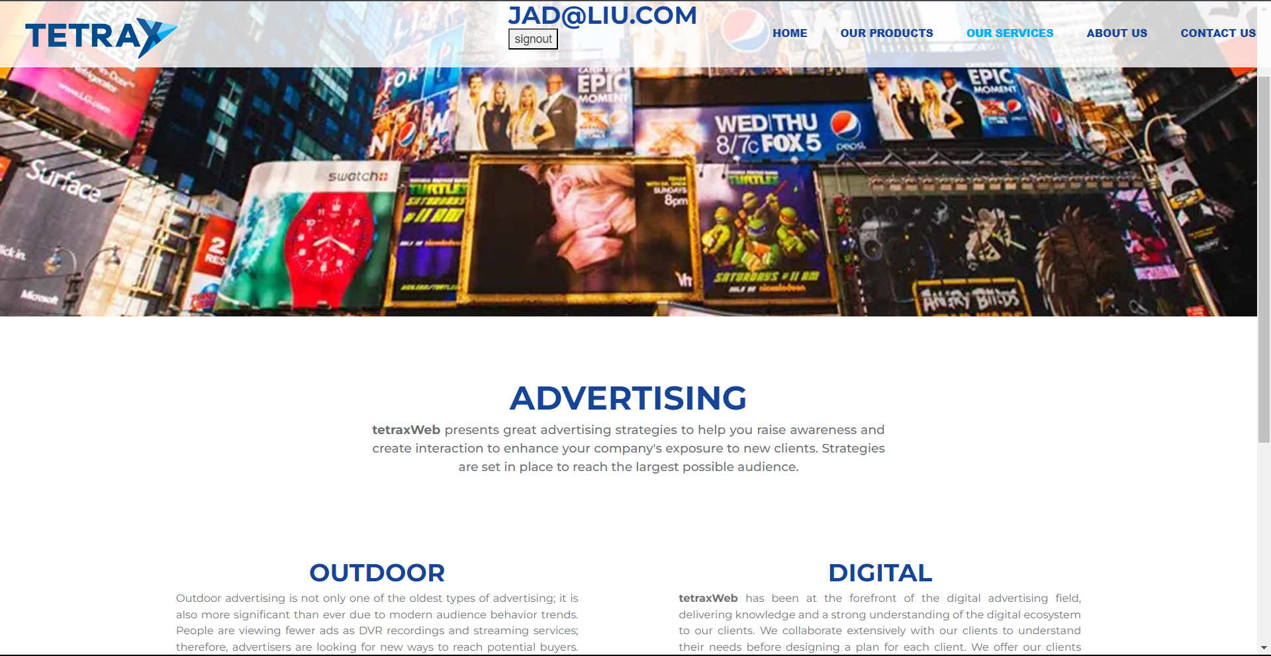

**Animation page:**

With cool animated video,

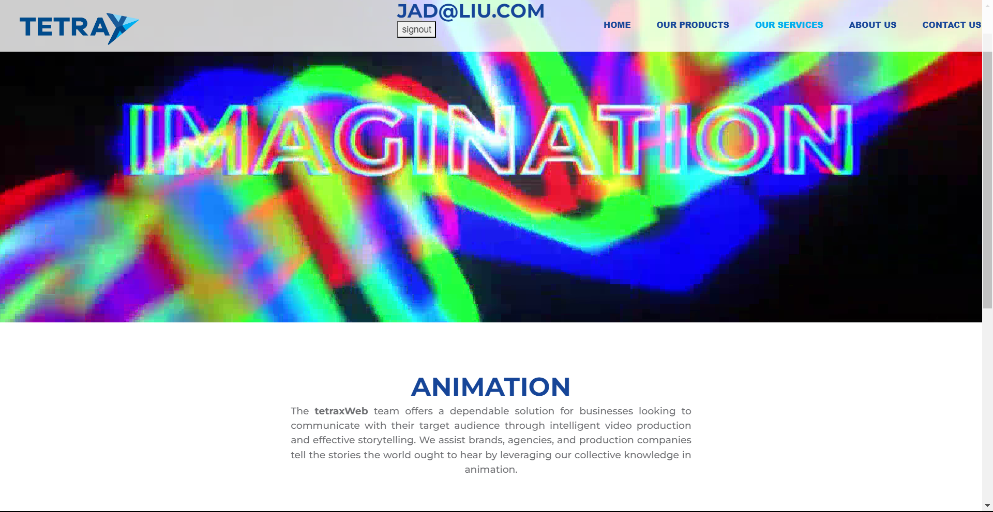

**Website Page:**

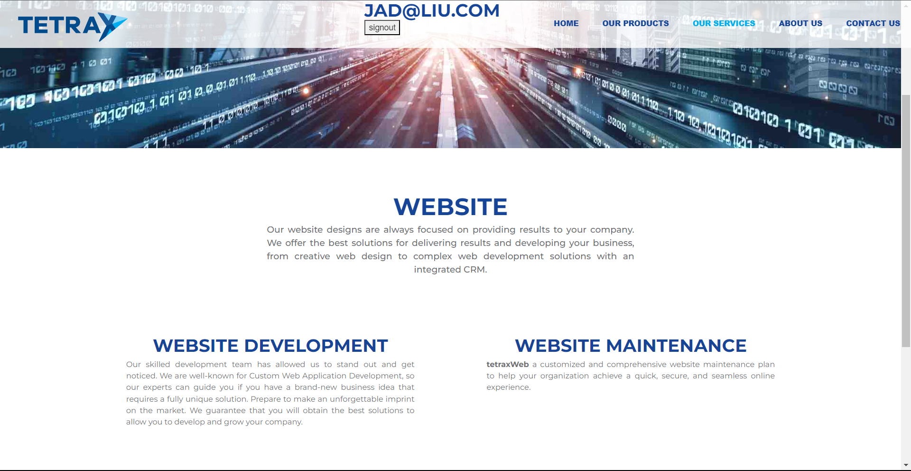

**Digital Marketing page:**

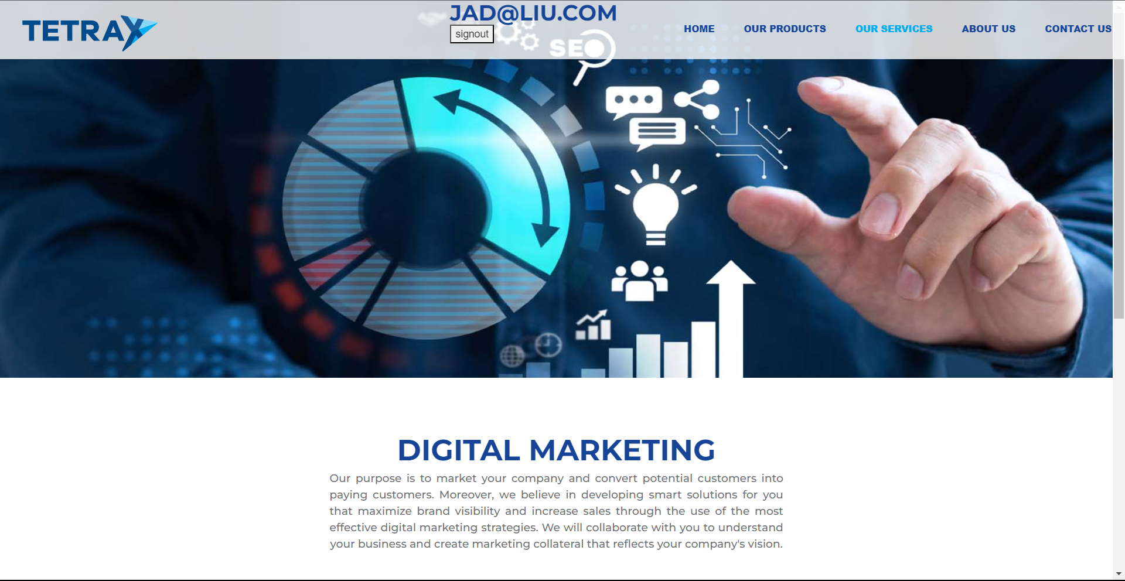

**4.2.7 – About us page:**

This page explains more about us and what mission, vision, and values are.

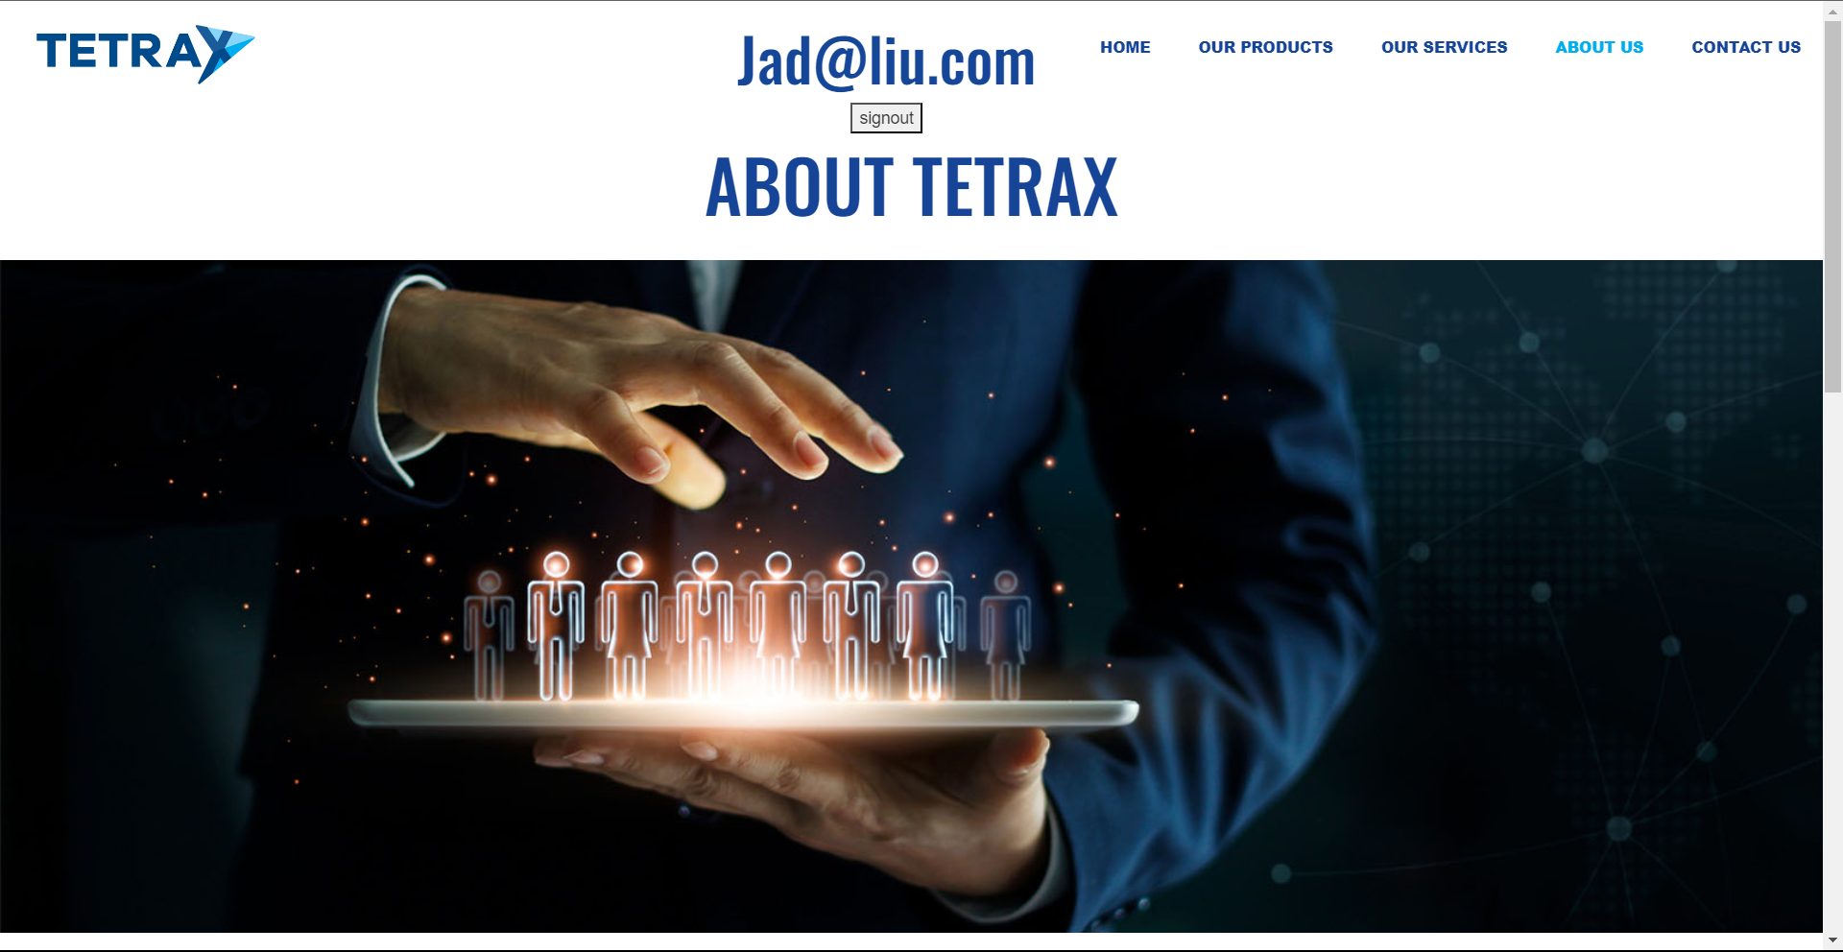

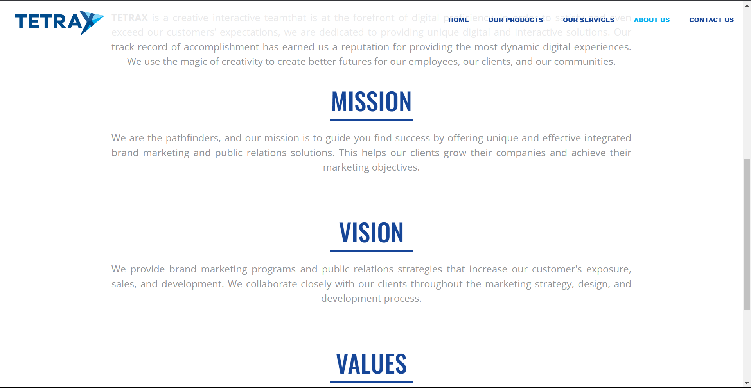

**4.2.8 – Contact us page:**

In this page a customer can contact us 24/7 and we will be ready to respond.

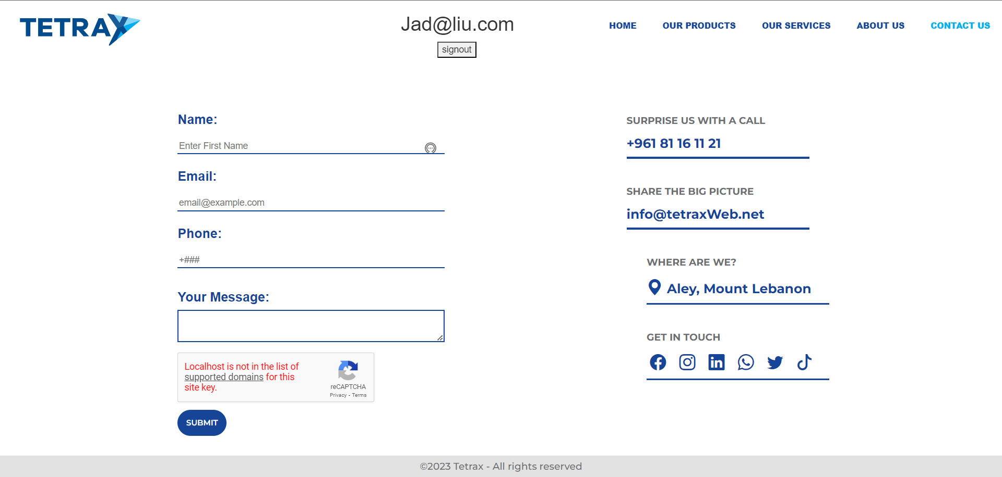

4.3.9 – Admin’s page:

Here an admin can update, add, delete services, and search the history for customers transactions.

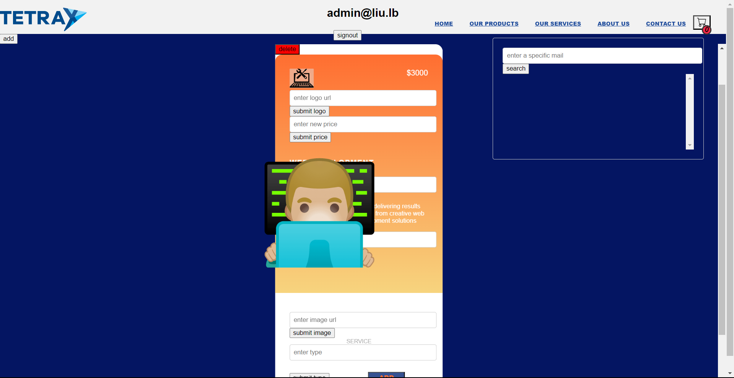

I would like to add that all pages in this website are responsive and can be used on any device and on any current browsers. Moreover, every page is SEO optimized. And the logo is clickable and redirects the user to the home page.

**5.2 Future Work:**

While we have successfully developed a functional website for our advertising team, there is always room for further enhancements and future work. Here are some potential areas to consider for future development:

**Enhanced User Experience:**

Continuously gather user feedback to identify areas for improvement in the website's usability and navigation.

Conduct user testing sessions to uncover any usability issues and refine the user interface accordingly.

Implement personalized recommendations and tailored content based on user preferences and browsing history.

**Advanced Analytics and Reporting:**

Integrate analytics tools to track website performance, user behavior, and conversion rates.

Generate comprehensive reports and insights on customer engagement, popular services, and conversion funnels.

Utilize data-driven decision-making to optimize marketing strategies and improve the effectiveness of advertising campaigns.

**Integration of Payment Gateways:**

Enable seamless and secure online payment options by integrating popular payment gateways such as PayPal, Stripe, or others.

Ensure the implementation of robust security measures to protect customer payment information.

**Integration of Customer Support Features:**

Implement a live chat or chatbot feature to provide instant support and assistance to website visitors and customers.

Set up a ticketing system to efficiently manage and respond to customer inquiries and support requests.

**SEO Optimization:**

Optimize the website's content, meta tags, and URLs to improve search engine visibility and organic traffic.

Conduct keyword research to target relevant search terms and enhance the website's ranking on search engine result pages.

**Mobile Application Development:**

Develop a mobile application for iOS and Android platforms to provide users with a dedicated and optimized experience.

Ensure seamless integration with the website's backend systems, including user accounts and purchased services.

**Social Media Integration:**

Integrate social media sharing buttons to allow users to easily share services and portfolio items on popular social media platforms.

Implement social media login options to provide users with a streamlined registration and login process.

**Continuous Website Maintenance and Updates:**

Regularly monitor the website for bugs, performance issues, and security vulnerabilities, and promptly address them.

Keep the website up to date with the latest technology trends, security patches, and software updates.

Add new services, update portfolio items, and enhance the website's content to reflect the advertising team's latest work and offerings.

By focusing on these future work areas, our website can continue to evolve and provide an even better user experience, attract more customers, and contribute to the success of our advertising team.

**References**

Developers, W. (n.d.). W3 Schools. Retrieved from w3schools.com: https://www.w3schools.com/

github. (n.d.). Retrieved from github.com: https://github.com/

stackoverflow. (n.d.). Retrieved from stackoverflow.com: https://stackoverflow.com/